**AWS cli**

1. Install aws cli on your PC

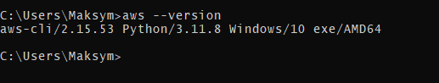

1. Create in your user account Programmatic credentials

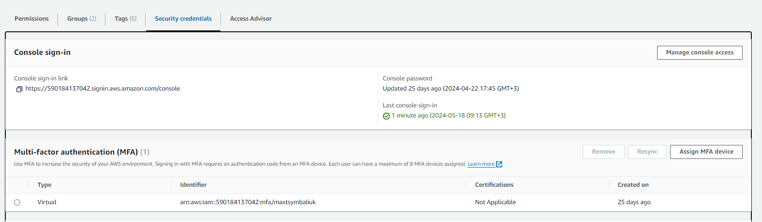

1. Add creds on your PC

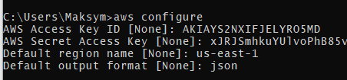

1. Switch to MFA session

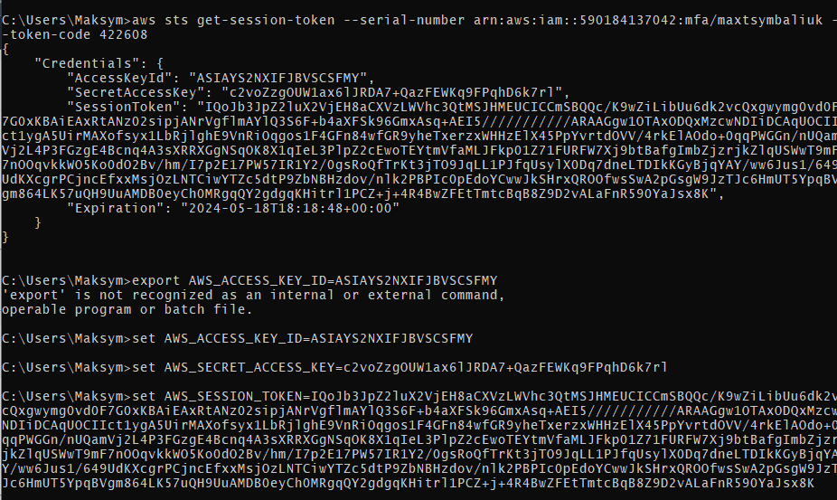

1. Make sure that you can perform command: aws s3 ls and see the list of S3 buckets

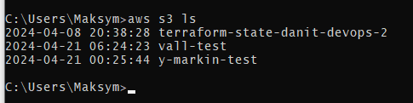

**Advanced**

1. create two ec2 instance: one with any tags, second - with tag "Owner=Your Name"
2. using aws cli write bash script, which will get the list of all running ec2, iterate over it.  
   If ec2 has tag "Owner=Your Name" then terminate it

Не можу створити ec2, пише помилку, що AMI образу не існує ☹

Скрипт додав до репозиторію, але через помилку не працює.